**Parallell Rsync Testing**

# * root level

32T cdar

66G standards/

18G admin

31G users

6.5T data_reuse

# * root/cdar level - folders in TBs

9.7T d419

2.9T d169

2.1T d325

1.7T d081

1.6T d657

1.6T d346

1.4T d516

1.2T d574

**Testing**

# Full Transfer

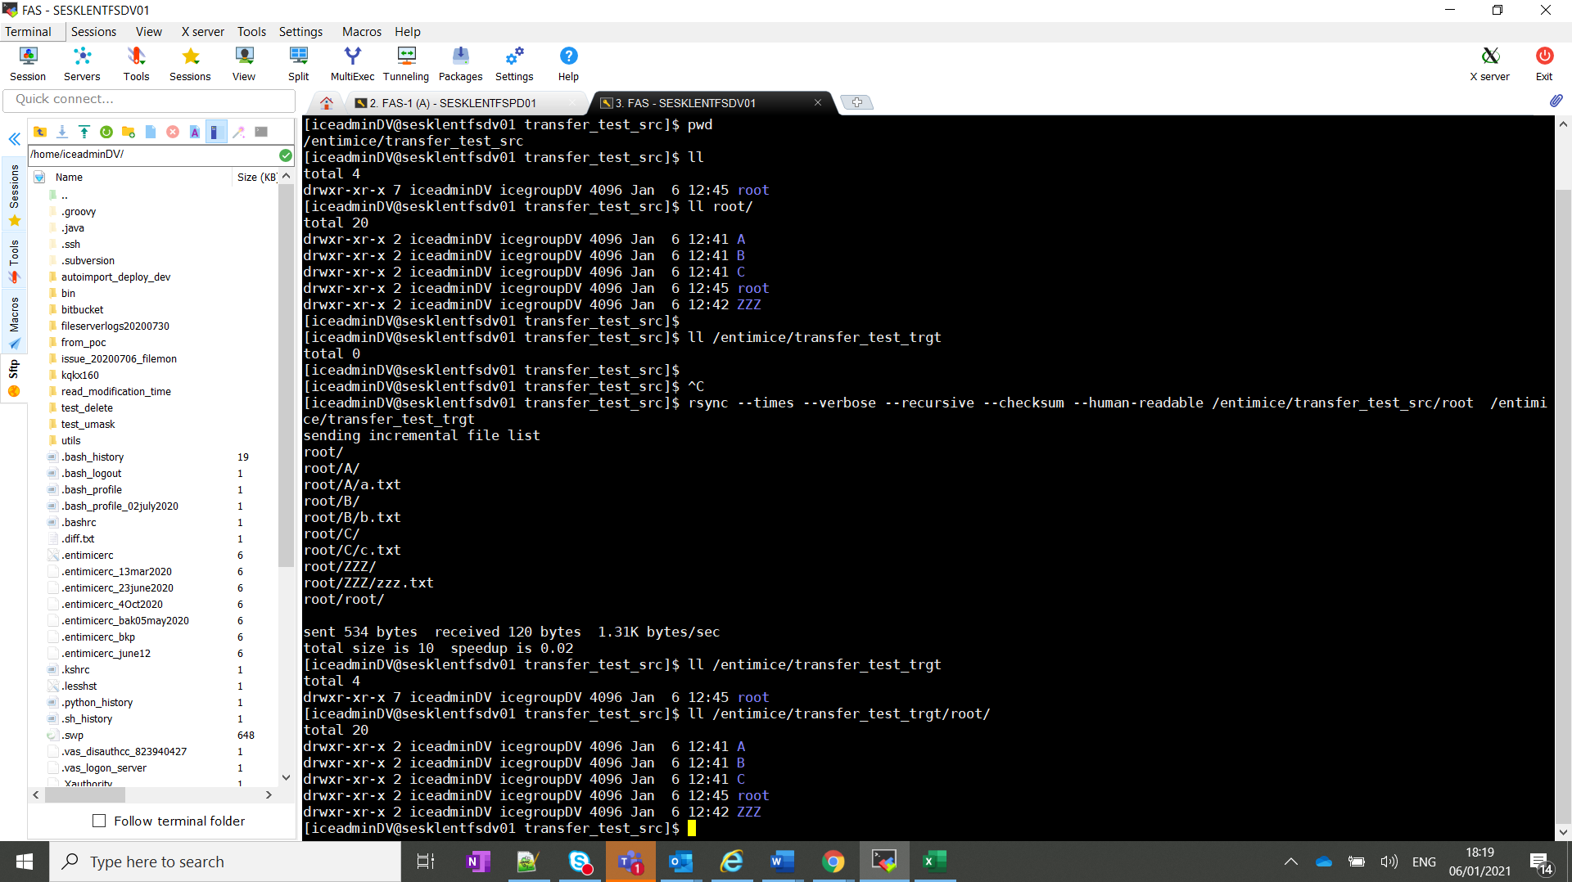

# Create new files under folder A and ZZZ

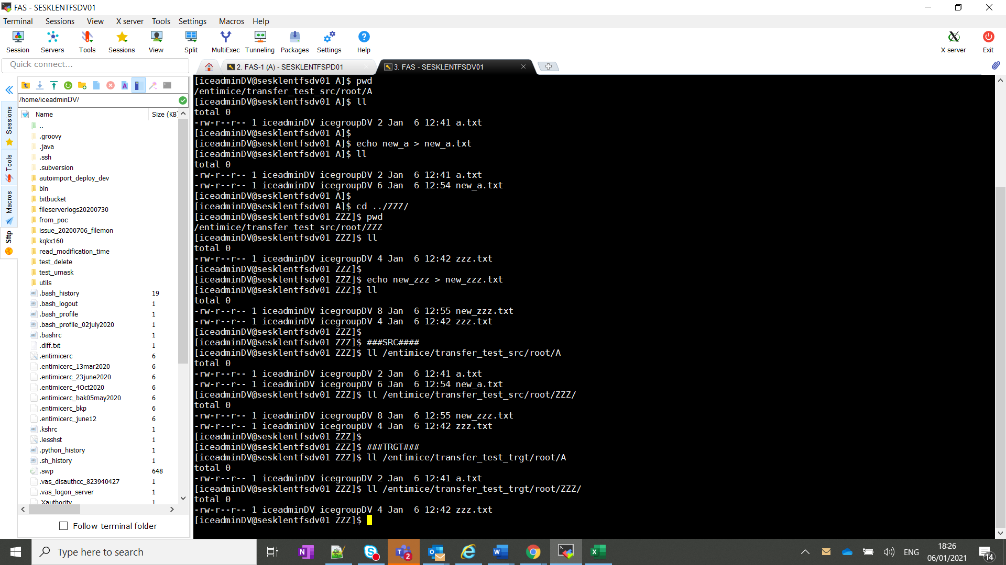

# Rsync again by excluding ZZZ

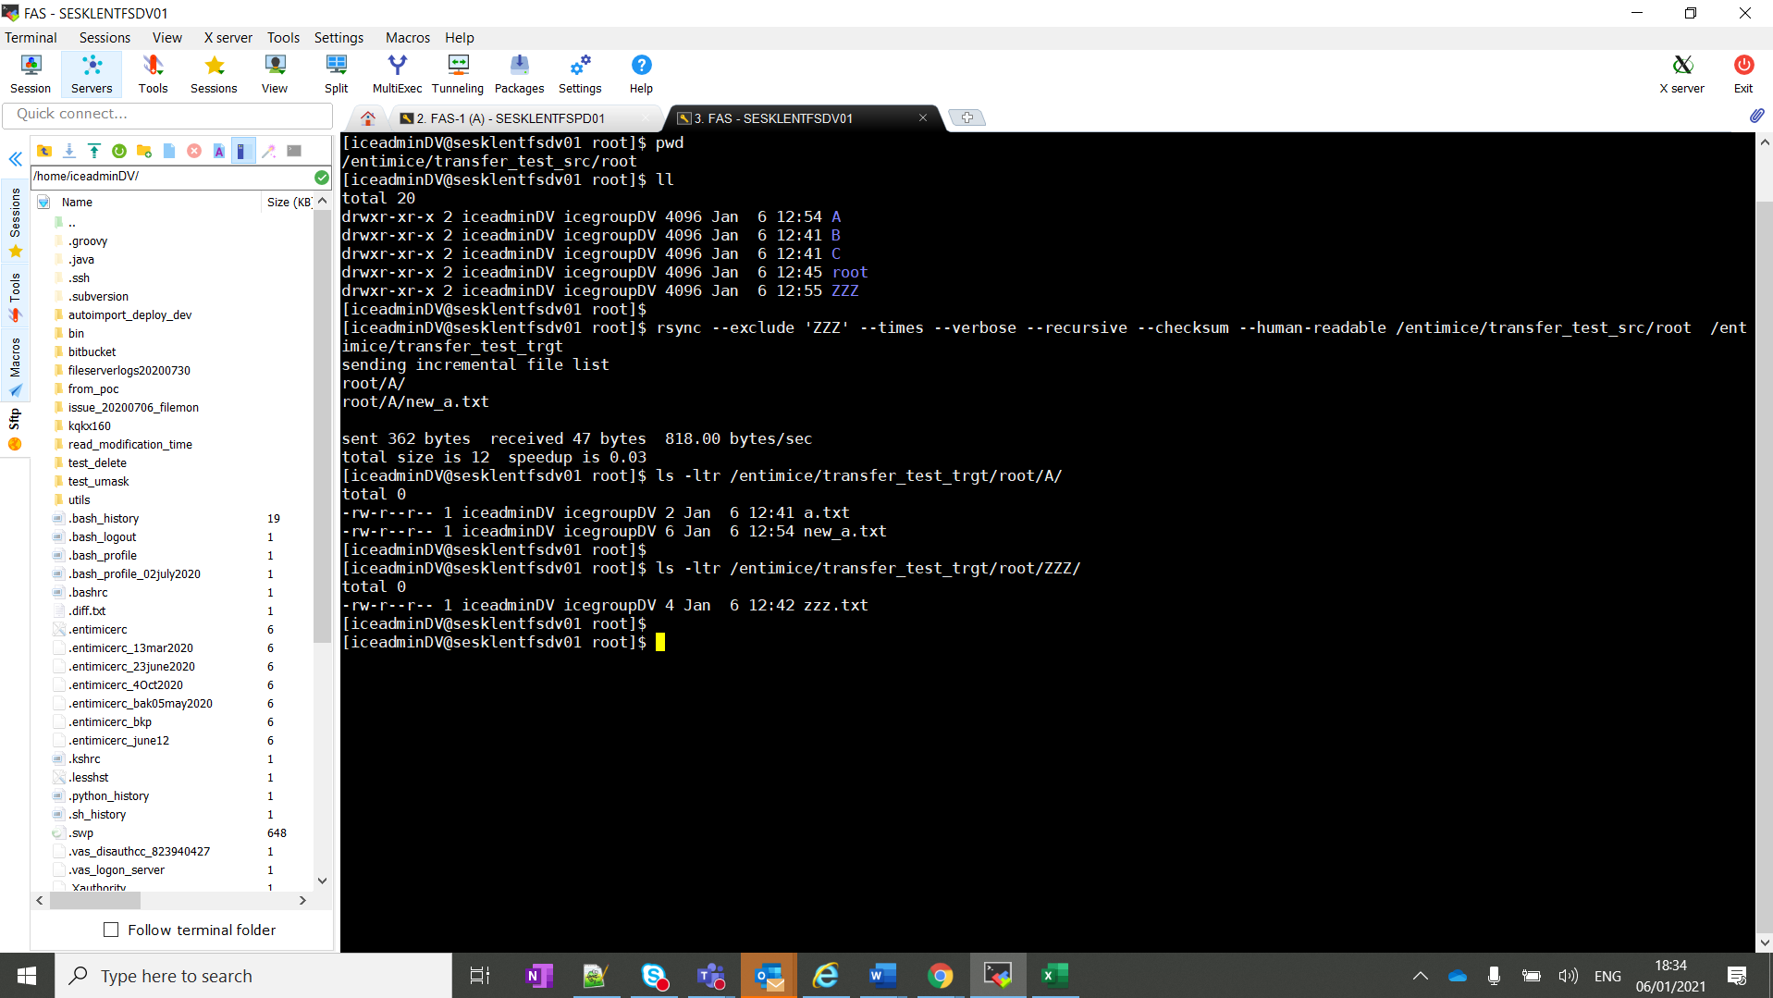

# Rsync only ZZZ separately

